Cidi Content Collection
Course Title & Code | Engaging in the Flex Online Process
Module | Getting Started
Module Learning Objectives | By the end of this module, you will be able to:  - Experience a Perusall assignment  - Analyze common misconceptions with online learning  - Develop content for the Getting Started Module  - Develop the course introduction discussion
Module Topics | - Best Practices in Teaching Online: Instructor Presence, Social Presence, Learning Communities, Humanizing Online Learning  - What is Flex Online?  - The Flex Online Process  - Milestones and deliverables  - Templates (Canvas and Course Development)  - ID/Faculty Working Process  - ID/Faculty Partnership  - Our commitment to accessibility

[TAB 1: Overview]
Overview: In Getting Started, you will be introduced to the Flex Online Course Development Process and the principles that guide it. This version of the workshop adds storytelling and AI. You'll build a central character and a storyline that runs through your course, and you'll use AI prompts to draft scenarios and activities that you then revise. You will get a clear picture of what to expect throughout the workshop and the development process that follows, including how your Instructional Designer will support you along the way. The module also covers several key best practices in online teaching, including instructor presence, social presence, learning communities, and humanizing online learning, all grounded in research and the federal requirement for Regular and Substantive Interaction (RSI). By the end of this module, you will have a solid foundation for the work ahead.

Introduction: Just as a well-run product launch requires careful planning before a single item ships, an effective online course requires intentional design well before the first student ever logs in. The Mays Teaching & Learning Innovation Team has developed a structured course development process grounded in research-based principles and built around the needs of adult learners. This module introduces you to that process and the people who will support you every step of the way.

[TAB 2: Best Practices in Teaching Online]
Effective online teaching is not simply a matter of moving face-to-face content to a digital platform. Research consistently demonstrates that online learners thrive when instructors are intentionally present, when courses are thoughtfully designed, and when the learning environment fosters genuine community. This section introduces four key principles that inform our approach, alongside an important federal requirement that shapes how we design for instructor engagement.

[ACCORDION 1: Regular and Substantive Interaction (RSI)]
Regular and Substantive Interaction, commonly referred to as RSI, is a U.S. Department of Education requirement for online courses that distinguishes distance education from correspondence courses. In practical terms, RSI means that instructors must initiate regular, meaningful engagement with their students, not simply make themselves available, but actively engage. This includes providing substantive feedback on student work, initiating contact through announcements or course communications, and being present in the learning experience in ways that go beyond automated course content. All of the best practices covered in this module are, in effect, strategies for fulfilling RSI in a thoughtful and pedagogically grounded way.

[ACCORDION 2: Instructor Presence]
Instructor presence refers to the degree to which students feel their instructor is actively engaged in the course. This includes being visible in the course, providing consistent and timely communication, and offering substantive feedback on student work. Research shows that instructor engagement and responsiveness are among the most significant predictors of student satisfaction and learning outcomes in online environments (Garrison, Anderson & Archer, 2000; Richards & Thompson, 2023). In practical terms, this means posting regular announcements, responding to student questions within 24 to 48 hours, and using a warm and direct tone throughout the course.

[ACCORDION 3: Social Presence]
Social presence is the degree to which students feel connected to one another and to their instructor as real people in the learning environment. Online learning can feel isolating, and courses that lack social presence often see lower engagement and higher withdrawal rates. Richardson and Swan (2003) found that social presence correlates strongly with student satisfaction and perceived learning. Building social presence requires intentional design. A well-crafted introduction discussion, regular peer interaction opportunities, and live cohort sessions all contribute to a course culture where students feel they are learning with others, not just alongside a screen.

[ACCORDION 4: Learning Communities]
A learning community is built when students and instructors engage in shared inquiry and meaningful collaboration. In Flex Online courses, learning communities are cultivated through a combination of asynchronous and synchronous elements. Peer review activities, discussion forums, and live cohort sessions are all tools for developing that sense of community. Research on bichronous learning, which blends asynchronous and synchronous formats, suggests this approach enhances student engagement while maintaining the flexibility online learners value (Martin et al., 2023).

[ACCORDION 5: Humanizing Online Learning]
Humanizing online learning is about ensuring students experience your course as a relationship with an instructor, not just a collection of content. This means using your voice and face in course media, writing in a conversational and approachable tone, and building moments into the course where students can connect with you as a person. Michelle Pacansky-Brock's work on humanizing online learning offers practical, research-grounded strategies that help instructors show up authentically in digital spaces (Pacansky-Brock, 2020).

[ACCORDION 6: Knowledge Check]
Question 1: Which of the following best describes Regular and Substantive Interaction (RSI)?
- a) Making course materials available to students online.
- b) Instructor-initiated, meaningful engagement with students.
- c) Auto-graded quizzes that give students immediate feedback.
- d) Scheduling optional office hours for students who need help.
Correct answer: b. Feedback: RSI requires instructors to actively and regularly initiate meaningful engagement with students. Making materials available or offering optional support does not fulfill the requirement on its own.

Question 2: Which of the following is an example of building social presence in an online course?
- a) Posting a detailed syllabus at the very start of the semester.
- b) A structured introduction discussion about students' goals.
- c) Sending an automated welcome email generated by the LMS.
- d) Assigning weekly readings with no discussion opportunities.
Correct answer: b. Feedback: Social presence is built through intentional opportunities for students and instructors to connect as real people. A structured introduction activity invites that kind of genuine connection.

Question 3: Humanizing online learning is primarily about which of the following?
- a) Reducing required assignments so students feel less overwhelmed.
- b) Making the course feel like a relationship with an instructor.
- c) Using the most advanced technology tools available in the course.
- d) Replacing videos with text readings for different learning styles.
Correct answer: b. Feedback: Humanizing your course is about authentic connection. It involves using your voice and face in media, writing conversationally, and creating moments where students can relate to you as a person.

[TAB 3: The Flex Online Course Development Process]
Now that we have introduced some of the principles that inform our work, let us walk through what the course development process actually looks like. Understanding this process will help you see where you are in the journey and what lies ahead. The Flex Online Course Development Process has three main parts: the Design Workshop, Content Development, and Quality Review. After these are complete, the course moves into Course Facilitation.
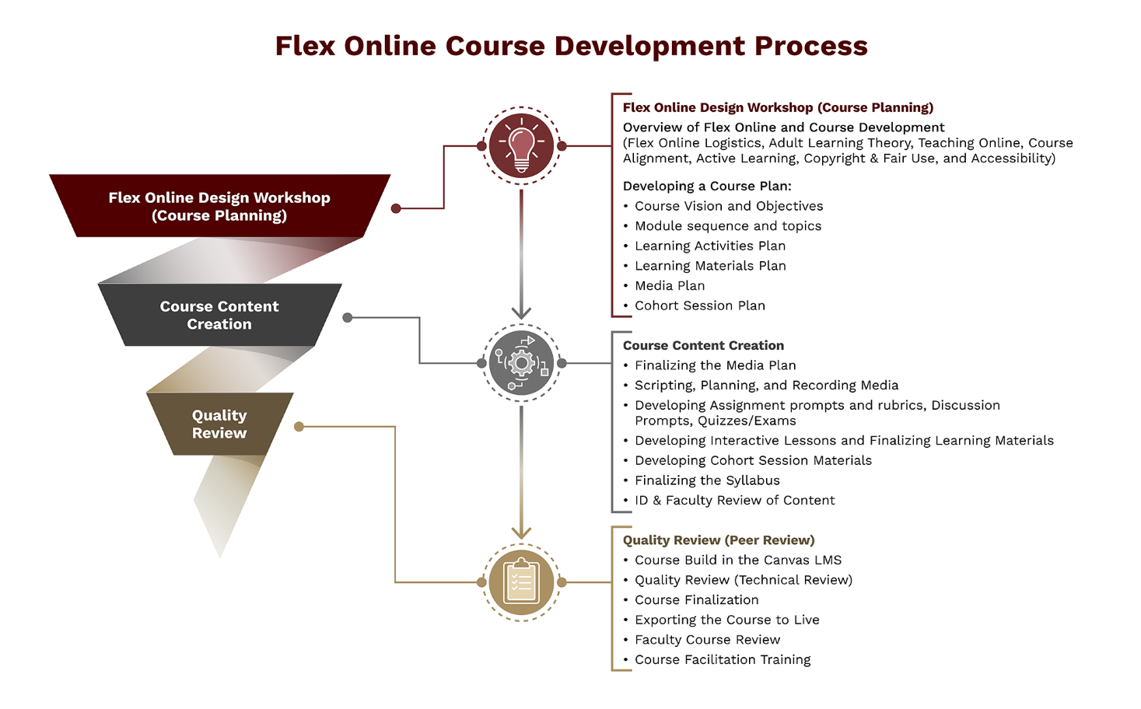
Figure 1: Flex Online Course Development Process, Redeveloped by TLI Media Team, 2026

[ACCORDION 1: The Flex Online Design Workshop]
The Flex Online Design Workshop is an eight-week experience where you will work with your assigned Instructional Designer (ID) to plan the foundational elements of your course. The primary deliverable from the workshop is your Course Planning Document, a comprehensive plan that will serve as a solid guide throughout the entire development process that follows. Think of the workshop as the architectural blueprint phase. The stronger the plan, the smoother the build. Your storyline is planned here too. Building a new course? Your character and storyline grow alongside your module plan. Redesigning a course? You'll build a character and fit your existing assignments into the story.

[ACCORDION 2: The Course Planning Document]
The Course Planning Document is the central artifact you will build throughout this workshop. It is a single working document that grows progressively as you move through each module. By the time you complete the workshop, it will contain everything you and your Instructional Designer will need to transition into the development phase.
The document is organized around the major planning decisions you will make across the eight modules. It includes:
- Your Course Vision, which articulates the purpose and direction of your course
- Your Course-Level Objectives, which define what students will be able to do by the end of the course
- Your Module Titles and Topics, which organize your content into a coherent learning sequence
- Your Learning Activities Plan, which outlines the assignments, discussions, third-party tool activities, and cohort activities your students will engage with
- Your Learning Materials Plan, which identifies the content you will curate and create for each module
- Your Media Plan, which identifies the recorded videos and graphics your course will need
- Your Cohort Session planning, which identifies the key activities that will drive your live sessions each week
You will receive the Course Planning Document at the start of the workshop. Your ID will orient you to it during your first meeting and will use it as a shared reference throughout both the workshop and the Content Development phase that follows.

[ACCORDION 3: The Kick-Off Meeting]
Once the workshop concludes, your ID will reach out to schedule a Kick-Off Meeting. This meeting marks the official start of the Content Development phase. During the Kick-Off, you and your ID will review your Course Planning Document, confirm which elements are ready to build, and work together to plan for milestone deadlines so that both your deliverables and the ID's work stay on track. Think of this as the moment construction begins.

[ACCORDION 4: Content Development]
Content Development is a 13-week process guided by your ID. During this phase, you and your ID work together to produce all the materials your students will encounter in the course. Your ID will build the course in a Canvas Development (DEV) shell and will coordinate with the Learning Media team to produce your video content. Shortly after the Kick-Off, you will participate in a Media Planning meeting with your ID and the Director of Learning Media to confirm the media assets for your course. If your scenarios need production, bring your scenario plans to that meeting. Interactive readings, discussion cases and narrated slide decks can be built without the media team.
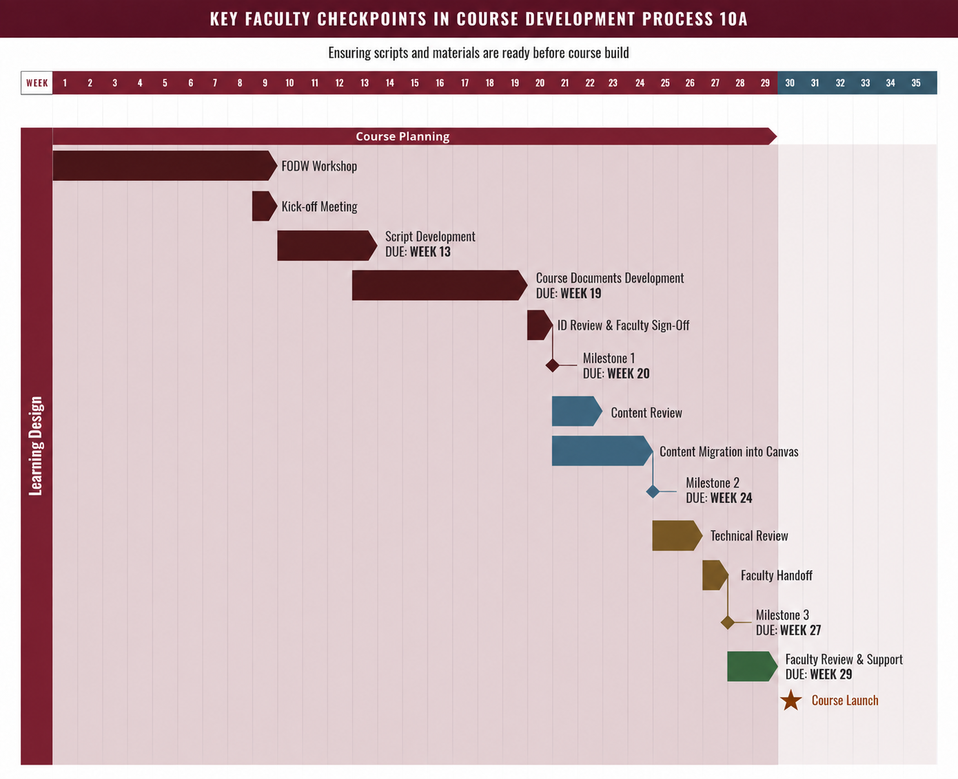
Figure 1 | Course Development Process Timeline. TLI Media Team.
[ACCORDION 5: Quality Review]
At the end of the content creation phase, the course goes through an ID Quality Review and a Peer Review. This review ensures the course learning materials, activities, and outcomes are in alignment and of high quality.
Once your course is fully built in the DEV shell, it undergoes another ID Quality Review and Tech Review. This is an internal process where reviewers verify that the course meets the standards established by the Mays Teaching & Learning Innovation Team. This includes checking that all materials are accessible, all links are working, the grade book is configured correctly, due dates align with the course calendar, and pages are consistently formatted.
Finally, there will be a week before the course launch where you will review the course for any last-minute, small updates. This will also be a time to familiarize yourself with the finished product. It will also prepare you for the course facilitation training.
[ACCORDION 6: Course Facilitation Training]
After the Quality Review is complete, you and your ID will meet for a Course Facilitation Training session. This is a focused meeting designed to prepare you to manage and facilitate your course independently. Following the training, there is a formal handoff. At that point, your ID steps back from the project, and the course becomes yours to manage. You will publish your course, typically the Saturday before the course launch, and from that point forward you are in the facilitation phase.

[ACCORDION 7: Course Facilitation]
Once your course goes live, you move into the facilitation phase. Facilitation in an online course looks different from teaching in a traditional classroom. The real teaching and learning happen as students engage with the course content. As the facilitator, your role is to guide, communicate, and assess. During your weekly cohort sessions, you have the opportunity to clarify concepts, guide discussions, and create opportunities for students to apply what they have been learning. You will not be on your own. Our support team will reach out to you once the course is underway to introduce themselves and provide guidance on the ongoing support services available to you throughout the term.

[ACCORDION 8: Knowledge Check]
Question 1: What is the primary deliverable from the Flex Online Design Workshop?
- a) A completed Canvas course ready for student enrollment.
- b) A Course Planning Document that guides development.
- c) A set of recorded instructional videos for each module.
- d) A finalized syllabus approved by the program director.
Correct answer: b. Feedback: The Course Planning Document is the central output of the Design Workshop. It captures your course vision, CLOs, module structure, learning activities, learning materials, and cohort plans, and serves as the blueprint for Content Development.

Question 2: What does the Kick-Off Meeting mark in the development process?
- a) The completion of the Quality Review phase for the course.
- b) The first meeting between faculty and the Director of Learning Media.
- c) The official start of the Content Development phase.
- d) The point at which the course is published for students.
Correct answer: c. Feedback: The Kick-Off Meeting follows the Design Workshop and signals the transition from planning to building. It is where you and your ID confirm the course plan and begin mapping out the 16-week development timeline.

[TAB 4: The ID/Faculty Partnership]
Throughout this entire process, your Instructional Designer is your partner. It is worth taking a moment to understand what that partnership looks like in practice.
Your ID is a skilled professional trained in pedagogy, project management, curriculum development, and technical course-building. Their role is to help you translate your subject matter expertise into an effective, accessible, and engaging online learning experience that is optimized for your students. To do that well, they will guide you on how to structure and build your course in ways that reflect best practices in online education. Think of them as the expert on the how, while you remain the expert on the what.
In practical terms, this means your ID will provide feedback on your design decisions, help you think through how your course structure and activities serve the student experience, flag accessibility and copyright considerations, keep the project moving, and build the course in Canvas. Your ID will also review your character and conflict against your course objectives before you move into scenarios, work with you through scenario planning, and coordinate any media production. They will not make decisions for you, but they will bring perspective and expertise that helps you make better ones. The partnership works best when both parties communicate openly, honor agreed-upon timelines, and approach the work as a genuine collaboration.

[ACCORDION 1: Portfolio Manager]
The Portfolio Manager oversees the progress of several course development projects simultaneously, ensuring that team-level and department-level standards are being met. They support individual IDs and can help escalate or resolve challenges that arise during development.

[ACCORDION 2: Director of Learning Design]
The Director of Learning Design coordinates with program directors to define the scope of course development projects and assigns portfolio managers and IDs to oversee the work. They also report project status and lead the development of course maintenance plans for the program.

[ACCORDION 3: Director of Learning Media]
The Director of Learning Media oversees the production of all video and multimedia assets for your course. You will meet with them during the Media Planning session to confirm the media plan for your course.

[ACCORDION 4: Director of Learning Delivery]
The Director of Learning Delivery and their team support you during the live facilitation of your course. They will reach out to introduce themselves and provide guidance on their services.

[ACCORDION 5: Knowledge Check]
Question 1: What is the primary role of your Instructional Designer?
- a) To decide which topics and content should belong in your course.
- b) To help turn your expertise into an effective online course.
- c) To facilitate your live cohort sessions on your behalf.
- d) To manage the program-level outcomes set by the department.
Correct answer: b. Feedback: Your ID is the expert on how to build an effective online course. They guide the design and build the course in Canvas, while you remain the subject matter expert responsible for the content.

Question 2: Which member of the project team oversees the production of your course videos and multimedia?
- a) The Portfolio Manager
- b) The Director of Learning Design
- c) The Director of Learning Media
- d) The Director of Learning Delivery
Correct answer: c. Feedback: The Director of Learning Media leads all video and multimedia production for your course. You will meet with them during the Media Planning session that takes place shortly after your Kick-Off Meeting.

[TAB 5: Key Terms]
SME (Subject Matter Expert): The faculty member responsible for the course content.
ID (Instructional Designer): Your primary partner throughout the course development process.
DEV Shell: The Canvas Development course where your ID builds and tests your course before it goes live.
Course Planning Document: The primary deliverable from the workshop, which contains everything you and your Instructional Designer will need to transition into the development phase.
Kick-Off Meeting: The meeting that marks the official start of the Content Development phase.
Quality Review: The internal review process that verifies your course meets research-based instructional design standards and team standards before it goes live.
Cohort Session: A live, 90-minute synchronous class session that provides students the opportunity to clarify, discuss, and apply what they are learning in the course.
RSI (Regular and Substantive Interaction): A U.S. Department of Education requirement for online courses mandating that instructors initiate regular, meaningful engagement with their students.
Storyline: The sequence of decisions a central character faces across your course, with each module made up of one or more scenarios.
Scenario planning: Laying out each scenario row by row: what students read or hear, what they see, and what they do.

[TAB 6: Conclusion]
You now know how a Flex Online course gets built: the Design Workshop, Content Development, Quality Review, and then facilitation. You also know who supports you at each stage. Your ID is your main partner from start to finish. They bring the design and Canvas expertise, and you bring the subject matter.
The best practices in this module are also how you meet RSI: regular announcements, responses to questions within 24 to 48 hours, real feedback on student work, and your own voice and face in course media. Your storyline supports the same goal by giving students a character and a set of decisions to work through across the modules.
As you start planning, keep the decisions your students will face on the job in front of you. You know those better than anyone, so let them shape the course.

References:
Freeman, S., Eddy, S. L., McDonough, M., Smith, M. K., Okoroafor, N., Jordt, H., & Wenderoth, M. P. (2014). Active learning increases student performance in science, engineering, and mathematics. Proceedings of the National Academy of Sciences, 111(23), 8410-8415. https://doi.org/10.1073/pnas.1319030111
Garrison, D. R., Anderson, T., & Archer, W. (2000). Critical inquiry in a text-based environment: Computer conferencing in higher education. The Internet and Higher Education, 2(2-3), 87-105.
Martin, F., Polly, D., Mraz, M., & Wang, C. (2023). Examining online learning research from 2020 to 2022. Online Learning, 27(2).
Oyarzun, B., & Martin, F. (2023). Collaboration in online courses: A systematic review. Online Learning, 27(1).
Pacansky-Brock, M. (2020). How to humanize your online course. Retrieved from https://brocansky.com/humanizing
Richardson, J. C., & Swan, K. (2003). Examining social presence in online courses in relation to students' perceived learning and satisfaction. Journal of Asynchronous Learning Networks, 7(1), 68-88.
Richards, G., & Thompson, C. (2023). Student perspectives on effective online teaching: A meta-synthesis. Distance Education, 44(1), 42-61.

